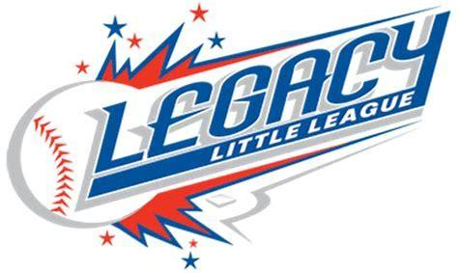
________________________________________________________________________________
Erik Knudson, President 303 Windmere Street (702) 757-8576 Henderson, NV 89074

Dear Valued Community Member,

We are asking for your help on behalf of Legacy Little League. We are a non profit organization, where all board members, coaches, assistants, team moms, and snack shack workers volunteer many service hours to allow kids ages 5 - 15 years old to develop skills and fall in love with the sport of baseball.

We are looking for businesses to form working partnerships with our organization to help us provide the best possible program for our kids. The expenses of running a baseball league are insurmountable. Some of the expenses include fees for fields, lights, insurance, and umpires. We also supply uniforms for players and trophies for end of the year tournament winners.

Partnership Program:
- Grand Slam: $10,000 = Business name or logo on player hats (entire league),
6 X 10 ft banner hung at all games, business ad on Legacy Little League website and Facebook page, business name on Opening Day flyer, Thank you plaque
- Home Run: $750 = Business name on the back of one team’s jerseys, 3 X 5 ft banner hung at all games, business ad on Legacy Little League website and Facebook page, business name on Opening Day flyer, Thank you plaque
- Triple: $500 = 3 X 5 ft banner hung at all games, business ad on Legacy Little League website and Facebook page, business name on Opening Day flyer
- Scholarship: $250 = help financially support families with more than one player. Business ad on Legacy Little League website and Facebook page, business name on Opening Day flyer

We thank you in advance for any support you may be able to extend to Legacy Little League and we look forward to working with you!

2018 Legacy Little League Board Members
Erik Knudson, President Andrea Damore, Player Agent
Rosslili Villarreal, Vice President Nicole Steidel, Safety Officer
Jessica Knudson, Secretary Christina Ortiz, Information Officer
Teresa Burns, Treasurer
_________________________________________________________________________________
Erik Knudson, President 303 Windmere Street (702) 757-8576 Henderson, NV 89074

Partnership Form

Business Name: _______________________________________________________
Business Address: ______________________________________________________
Primary Contact(s): _____________________________________________________
Email: ___________________________________Phone: ______________________
Level of Partnership being Requested: (please circle one)
Grand Slam Home Run Triple Scholarship

Policy:
Sponsorship of the Local Little League does not permit the Sponsor to have any rights or responsibilities in the operation of the Local Little League or any team in the Local Little League, nor does the Sponsor have any rights or responsibilities in the selection of managers, coaches or players for any team in the Local Little League. Nothing herein shall make us joint ventures. The Sponsor and the Local Little League are independent contractors with respect to one another, and neither shall have any authority to represent or bind the other in any manner or to any extent whatsoever, except as specified herein. Any reference to the Sponsorship under this agreement must make it clear that the Sponsorship is with the Local Little League ONLY, and NOT with Little League Baseball and Softball, the organization. Use of the marks of logos of Little League Baseball and Softball by any local sponsor is prohibited, unless permission is expressly granted in writing by Little League Baseball, Incorporated.

By signing this I, the sponsor, acknowledge the sponsorship policy and agree to adhere to all components of this policy. If I fail to adhere to this policy, Legacy Little League has the right to revoke my sponsorship.

Accepted and agreed to:
Advertiser Contract Signature: ____________________________ Date: ____________
Print Name: __________________________________________

Legacy Little League is a 501(c)(3) Non-Profit Charitable Organization.
EIN # 88-0293188
Sponsor Form and Checks can be mailed to:
Legacy Little League ℅ Erik Knudson: 303 Windmere Street, Henderson, NV 89074
Or arrangements can be made for pick up by calling Erik @ (702) 757-8576

